Wordpress: An Incredibly Powerful Blogging system!

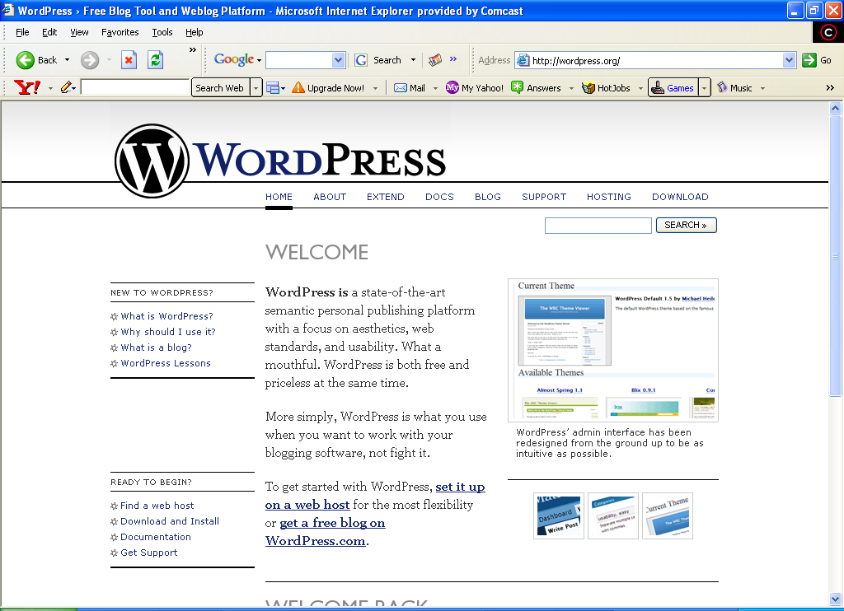

Table of Contents

Wordpress basics
Why Wordpress (v Blogger)
How to install a Wordpress blog
Wordpress templates
Best free template resources
Best paid-for template resources
Wordpress plugins basics
Wordpress plugins how to install
Wordpress plugins best free resources
Wordpress plugins best paid for resources
Conclusion

Why Wordpress?

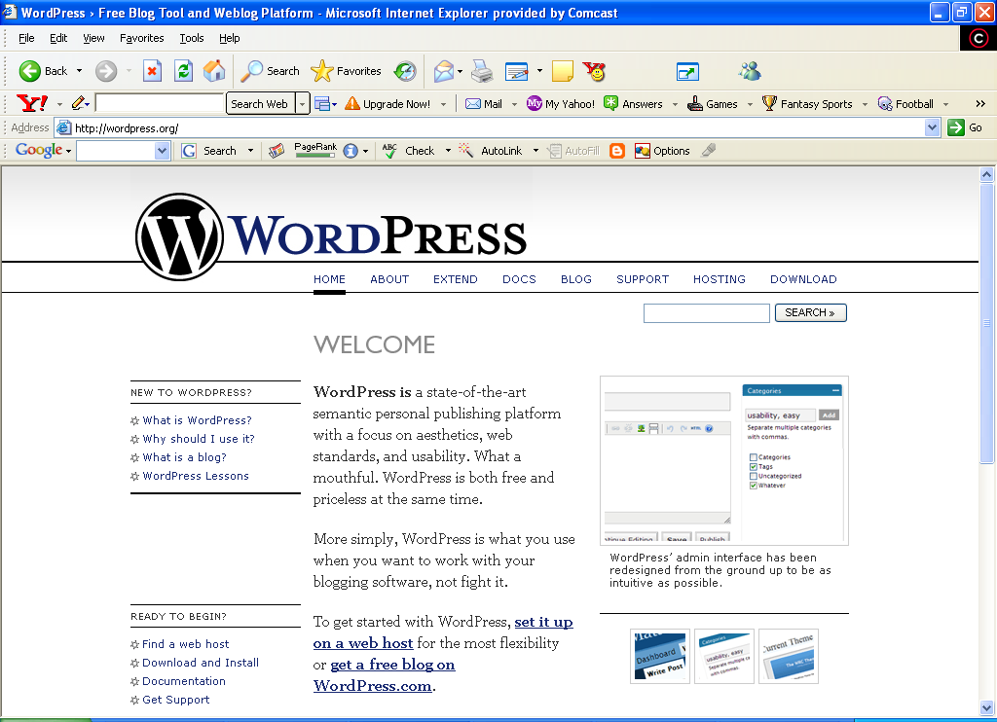

So why choose Wordpress?
You might have heard rumors about Wordpress websites, like for example you may have heard that Google gives priority to these websites. It is fairly certain that search engines give priority to certain websites and blogs, so now that blogging and pinging phase might be losing at least part of it’s effectiveness, now is the time for something new.
There’s strong evidence that Wordpress blogs get better search rankings than other sites. We will explore that in more detail later, but for now just know that there are some search engine advantages to using Wordpress tools.
In some ways this tool is only good for those who understand the importance and advantages of blogging. Blogging is a form of website promotion and information sharing that can have very strong business implications.

Wordpress Blogging
What is the so special about Wordpress? Wordpress is your simple and easy way to set up a blog with minimal programming requirements. Wordpress gives you a plethora of themes, theme resources, and the ability to use images, and various blog designs and layouts. I can elaborate all day about the basic features and benefits of Wordpress, but I have to admit that most of us use Wordpress for one simple reason. We use Wordpress to make money.
Here's a quick example of how Wordpress can change the way you blog forever:

You have a few websites and already are earning some decent money from them so you have a full time programmer on retainer. You've heard about Wordpress and how it would allow you to set up your blogs with little or no effort.
You like the idea but don't want to pay the programmer so you decide to tackle it yourself. It's easy to downloaded the pages and open an FTP connection to your website. You then uploaded the documents and set up the database connection. Within minutes, you are working with a Wordpress setup on your website. It was that easy.

You can now set up all the theme, feeds, and template tags you need. All done within an hour. After this, you would simply copy this setup to other websites and change the header information to the match requirements at your other websites. You accomplish all this in less than 30 minutes.

Best of all you didn’t need to take up your programmer’s valuable time.

You can then go on to embed Google Adsense ads and other advertising in the blogs. A few strategically placed links on pages that are already indexed and your blogs are up and running!

Wordpress and high-end blogging tools like it can simplify the arduous process of setting up a blog or blogging system. Wordpress is VERY easy. Below is a Wordpress blog I set up in 30 minutes:
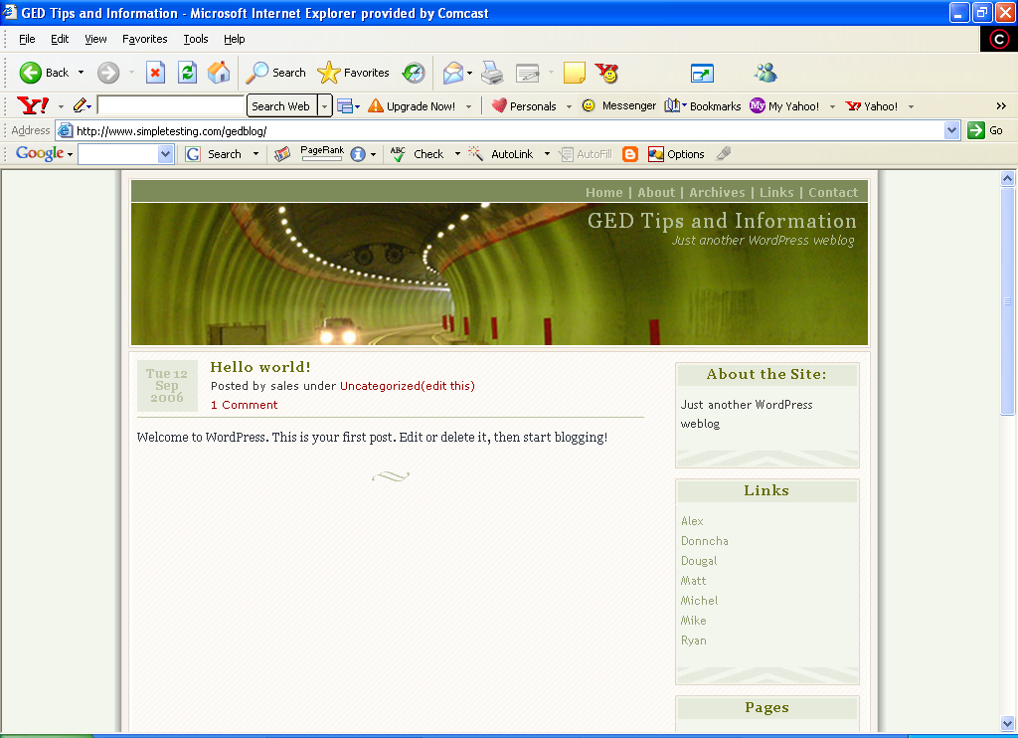

30 minutes includes download, code extraction, upload, database set up and installation. While I did not do heavy customization, it would have been very simple to do through the interfaces that are available through the Wordpress administration tool. The basic steps to uploading the Wordpress tools are:

- Instructions (Read them!)
- Download the package. You should download the Wordpress tools and extract them from the website package.
- Create a website to upload the Wordpress tools to. I used a reseller website. This means I have more than 10,000 domains I can upload to and more than 1000 sub-domains I can use for every top-level domain. I get all this for $33.00 USD per month. (www.redfoxhosting.com)
- Upload the Wordpress files
- Go to your website www.yourwebsite.com (index.php is the default page that Wordpress opens to)
- Go to your website and pull the MySQL database information (a) Username, (b) Password, (c) Server Information [This information will be available in your database control panel.]
- Go to the website and answer the questions on your database (When you start Wordpress on your website, it will ask you to answer several questions, answer those questions with the database information from #6.
- Input your set up information, and set up the links and layouts of the website

Why Wordpress instead of Blogger?
Have you ever used blogger? I am referring to www.blogger.com. Blogger.com and LiveJournal.com are some of the best-known blogging websites on the internet. Unfortunately there is one MAJOR drawback, you don’t own the website. At any time blogger can delete your username and profile. Lots of work and effort poured into someone else’s websites is not what you want to do. It is not in your best interest. This is the perfect example of how no business built on Blogger or LiveJournal.com is actually yours. These blogs generated income in the order of about $500 -$3350 per month. This income included a collection of Adsense and Commission Junction revenue. Unfortunately, both Blogger.com and LiveJournal.com reserve the right to kick you off. Only a website put together with your own pages affords you a viable business that you own. You should never put your business and hours and hours of your work into a website you do not own and cannot control.

Features and Benefits of Wordpress
There are also not a million other files for you to upload. This system is easy to download, and easy to upload to your own personal websites. Wordpress is built to W3C standards for XHTML and CSS. These features make Wordpress code easier to manage and easier to render in standards-compliant browsers. Non-compliant browsers are made compliant with only a few changes.

Wordpress websites also have some very positive features like themes, non-compiling changes to the website and the ability to utilize plugins. The most positive factor in the Wordpress utility is that you do not need to know php. With many blogging systems you often need to know how to program. With Blogger, I spent hours embedding Google ads in the pages. Also when I made changes I had to recompile the script or “rebuild” it. This took time while I waited. Imagine how much time you can spend “rebuilding” dozens of blogs! In each blog I modified each blog and linked it to my central website. Linking blogs that get regular traffic is a technique called “hub and spoke” theory.
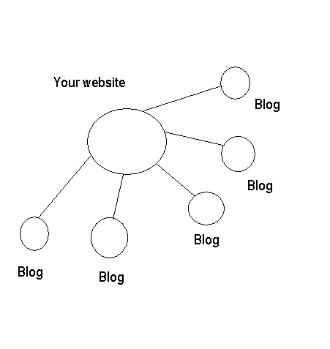
In this scenario, you have to see how you can arrange your blogs to produce traffic for a central website. This is an excellent tool to produce income for your business. Wordpress has the potential to be the perfect tool for your business to generate an average level of traffic to a central website. The relative advantages are:
- You don’t have to know php.
- You don’t have to know how to program at all.
- You don’t need to use the Wordpress hosting service. Although this is offered, it is not necessary.
- Wordpress has aggregator support for standard RSS configurations. This has already been done with Atom.
- Wordpress automatically connects and configures with MySQL with virtually no effort.
- Being built to standards increases Wordpress’s longevity and future internet adoption
- Wordpress automatically imports images.
- The Wordpress template has built-in links added in the template.
- Wordpress allows for the customization of metadata.
- Wordpress allows customized styling for printing.
- Wordpress allows the administrator to design headlines.
- Wordpress allows for categories.
- Wordpress allows for customization of the sidebar.
- Wordpress allows for customized RSS Feeds.
- Wordpress allows for customized forms.
- Wordpress allows for basic blogging posts.
- Wordpress allows archiving for posts.
- Wordpress allows for contacts in the template.
- Wordpress allows for an “about” page.
- Wordpress allows for the styling lists and is built with CSS.

How to Install a Wordpress Blog (Step-by-Step)
Presented here for you is a more detailed explanation of how to install a Wordpress blog.
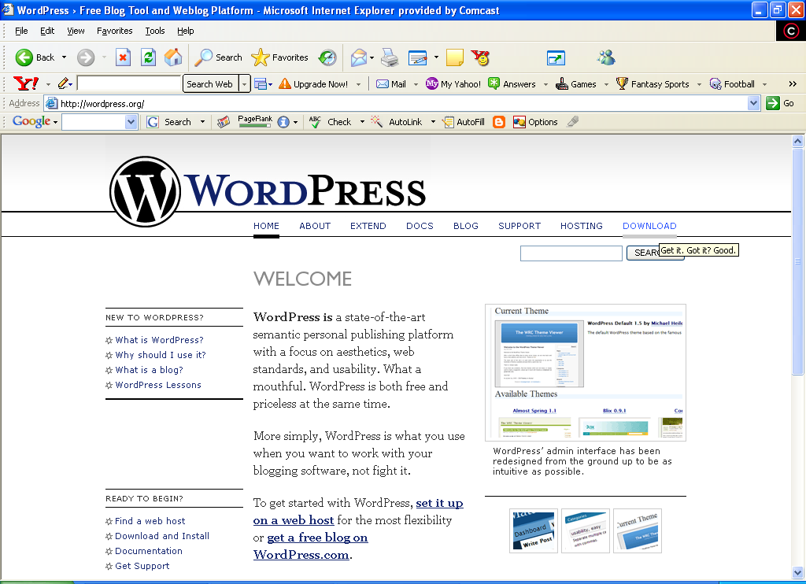
This is the Wordpress website. It is located at:
http://www.wordpress.org
- You can click the above to get to the website.
- You will go to the “Download” Link.
- Click “Download”
*Please note we assume you have already read the instructions.

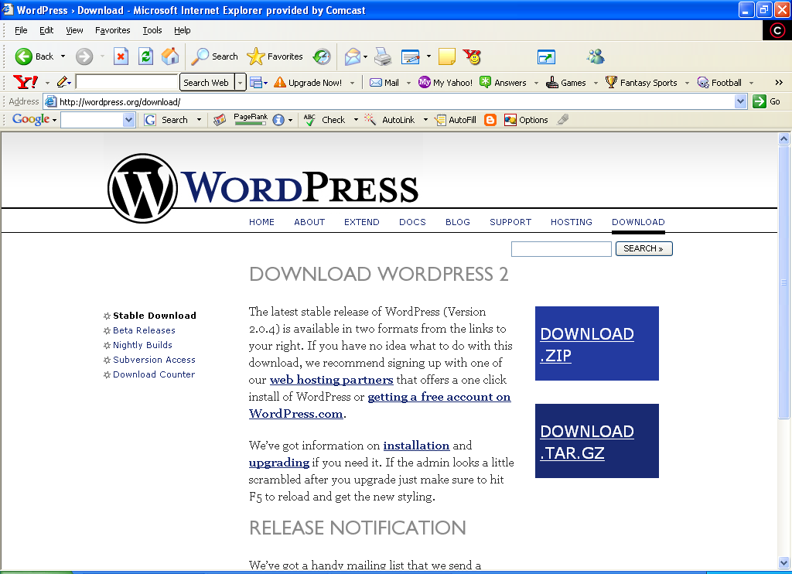

- You will choose a download format, ZIP is probably best and easiest. The program for extracting this file is called WinZip. You can download it for free at www.winzip.com.

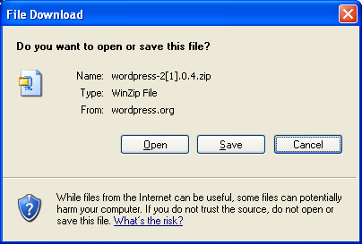

5. In this frame you will choose to save the zip file. You do not want to click “Open”. It may extract into a partition on your PC that you can’t recover the files from easily.
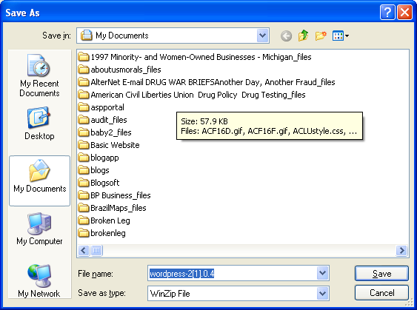

6.You will want to save the .zip file in a location to extract it from later. You will want to remember this file location. Please write it down.
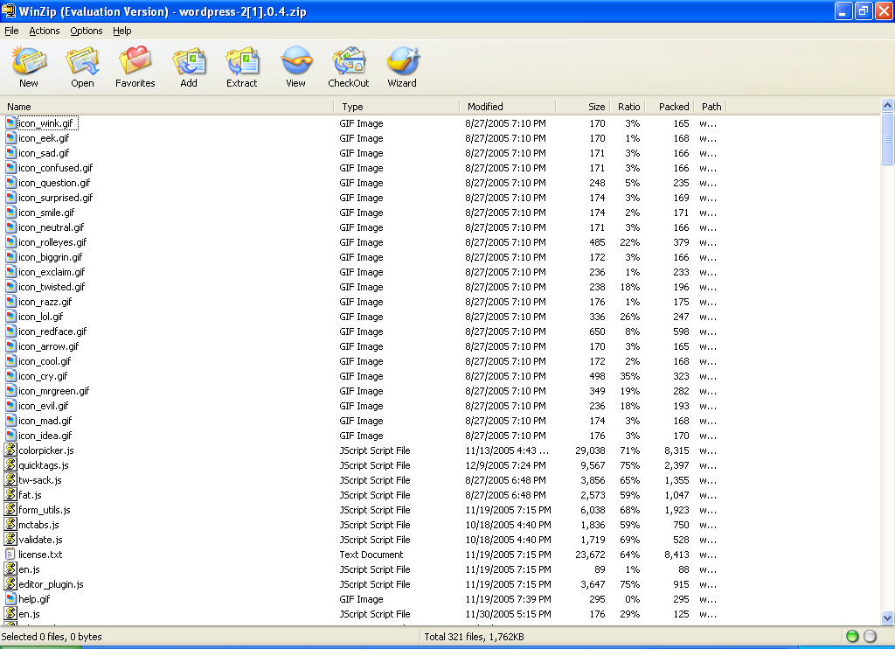

7. Once you click the WinZip file, it expands into a full file list.

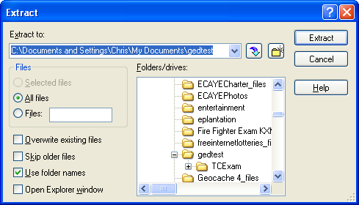
8. In this case, I will extract to a local folder on my PC. The full extract process will run in less than 1 minute. Next, click “Extract”.

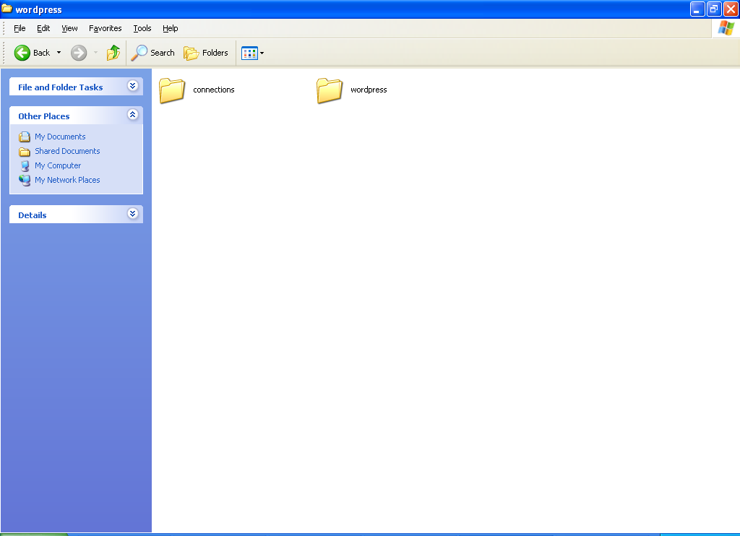
9. The Wordpress folder will appear in your extract folder with all associated sub-folders.
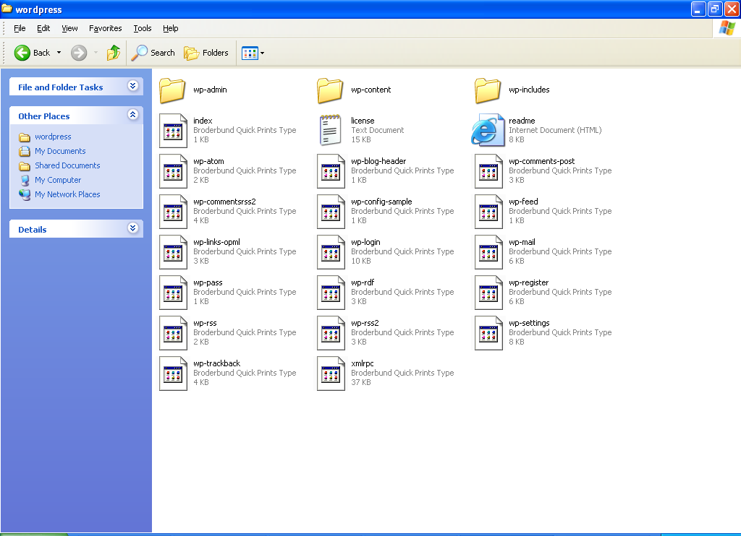
10. The Wordpress folder and its contents are listed above. These are contents you will extract and copy into your website.

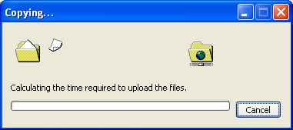

11. Next you will copy and paste these contents into your on-line FTP directory. If this is done from within Windows, this is a “drag-and-drop” or “copy and paste.”

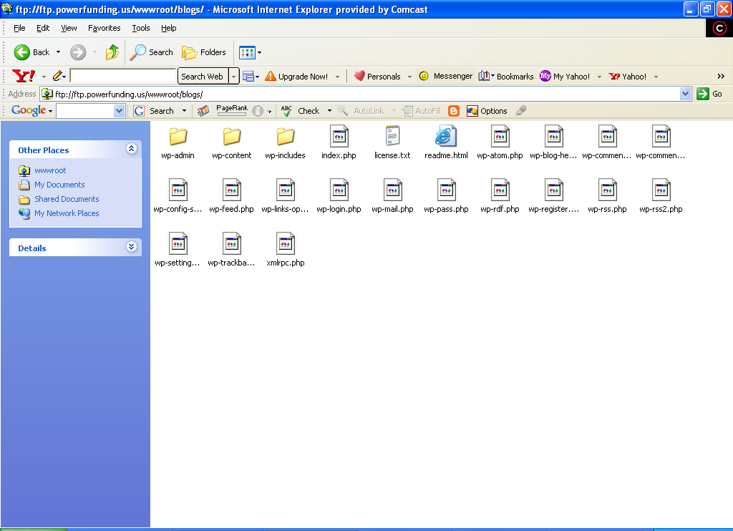
12. Paste up all the files and folders below the “Wordpress folder” in your extract.

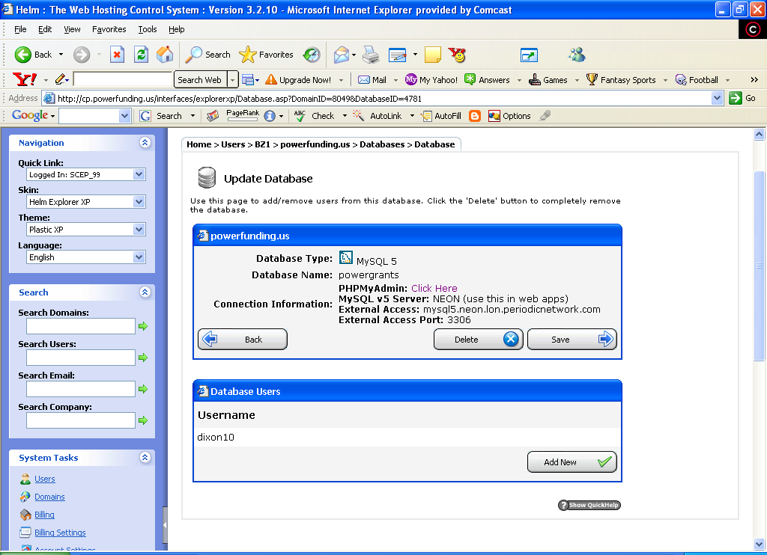
13. In my website control panel, I established my database connectivity and set up a username and password. You should copy down this information, and if you need your web provider to set this up for you, you should get the following information:
- Server Name
- Database Name
- Username
- Password

14. After that, you will go to the main website and finish your set up.
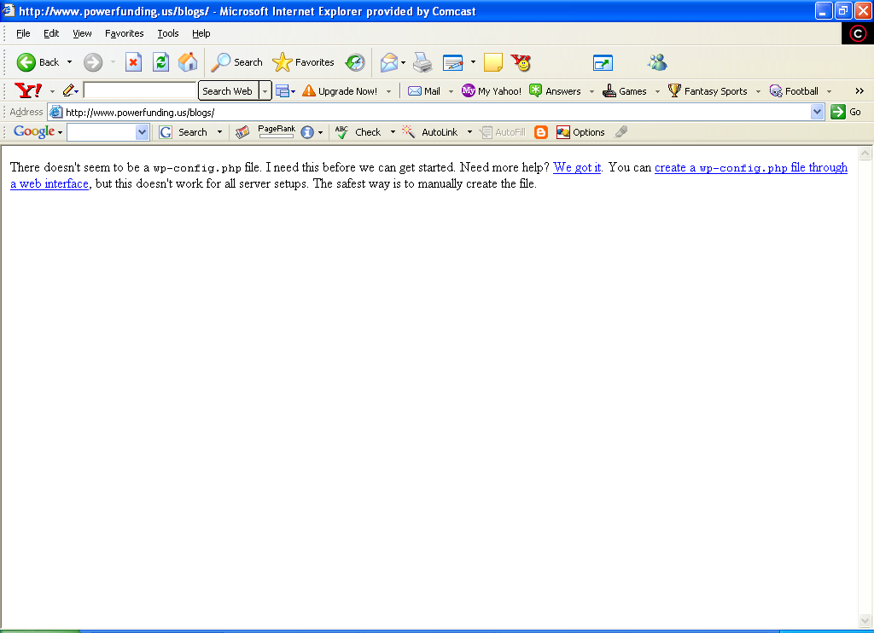
15. In this frame, you probably will not have a configuration file, so you will put the database information into a page specifically designed to launch your website. Click the “create a wp-config.php file” link.

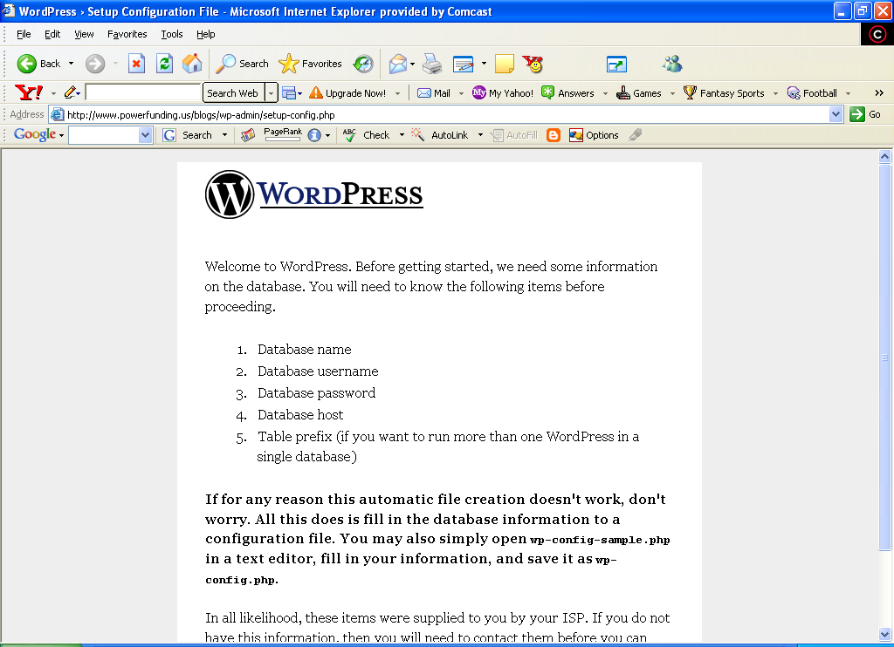
16. This page comes up. You will make sure you have all the required information we mentioned earlier and fill it in on the next page. Click “Let’s go” link at the bottom of the page.

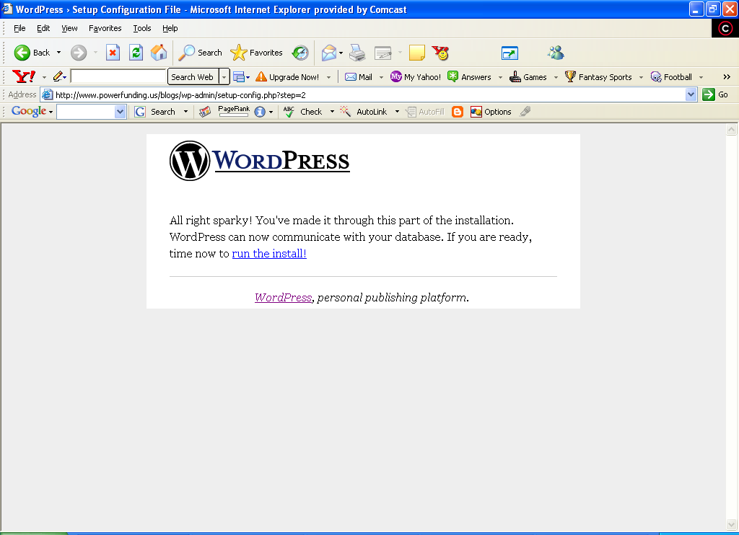
17. You should get a confirmation that everything is a go, and that the database was found. Lastly, you click the “run the install” link and you are at the last step before the actual on-line install.
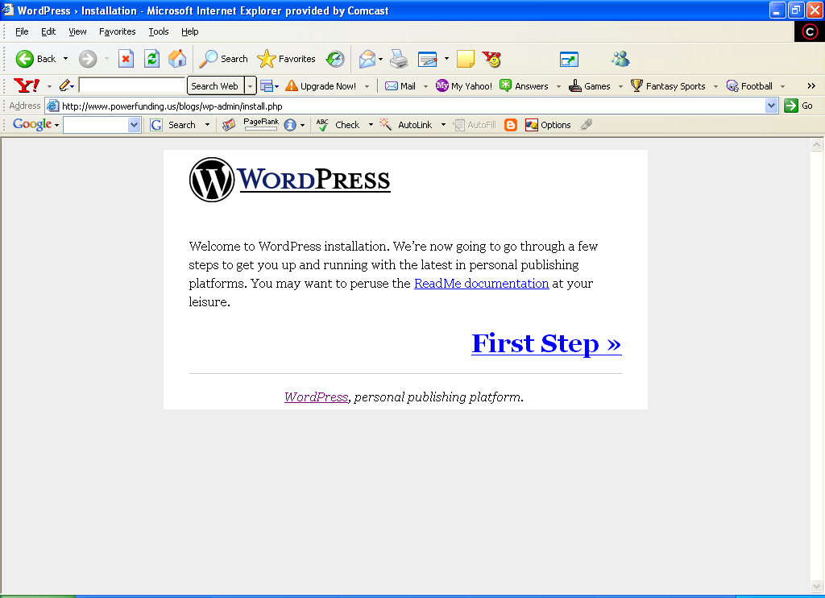
18. Your install has begun and the system briefs you how you should have read the documentation. Please take some time to review this in case something doesn’t go as planned.

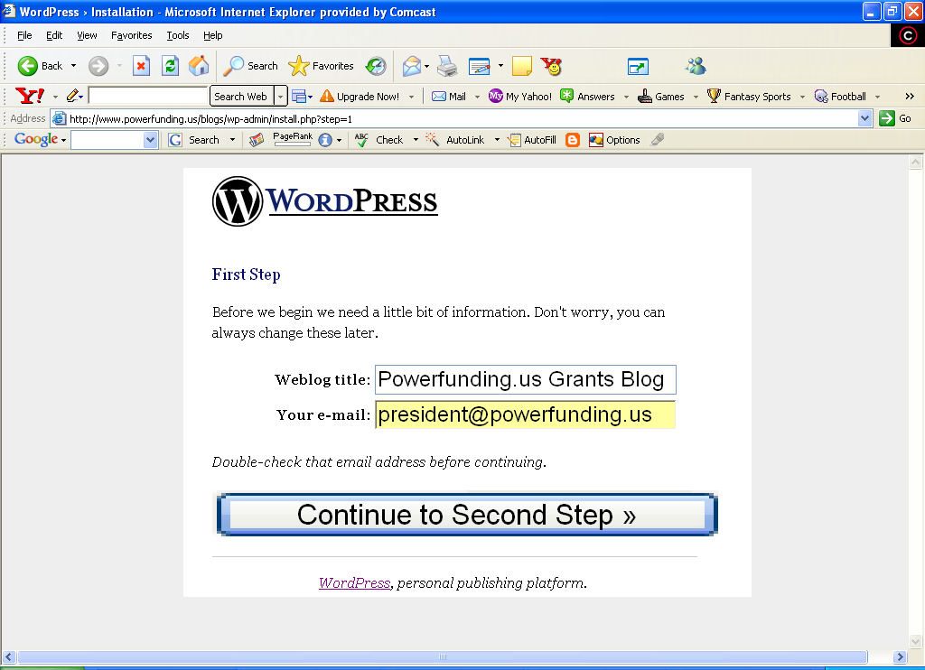
19. Fill in the information you want blog correspondence sent to. This should be a primary “catch-all” account. I filled this field with my generic website account information.

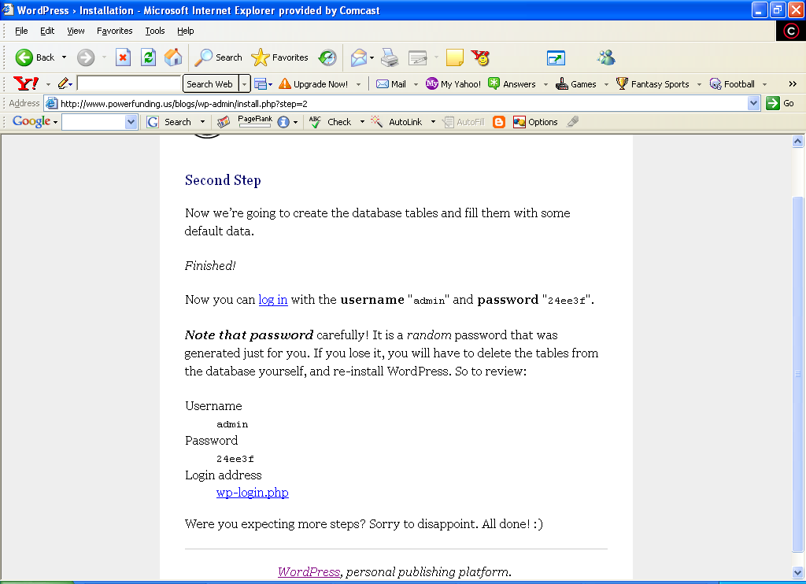
20. Now you will log in as admin and finish the installation. This is where you will define the look and feel of your website.

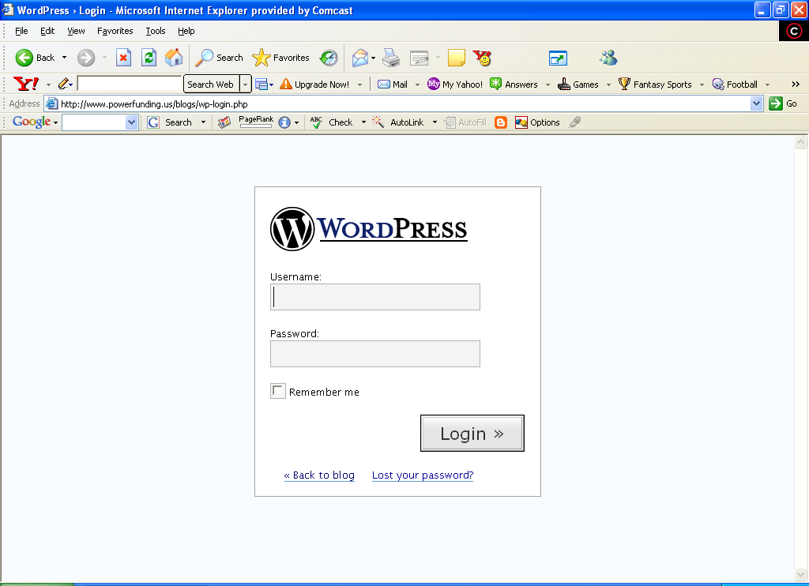
21. You will go to your administrative page and login with the administrative password.

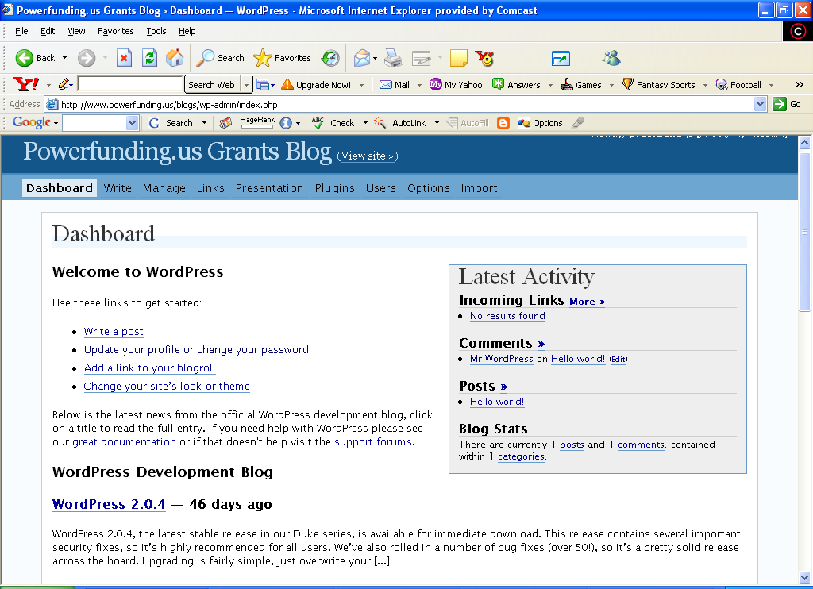
22. You now have access to modify your theme or look and feel and change your web log in anyway you see fit. Our specific instructions stop here, as users will want to customize different aspects of their blogs.

Wordpress Templates & Themes
While themes generally describe the “skin” of the website. A skin includes colors and photos. Themes are downloaded and put into the “themes” folder in your website. Shown below is the theme page on Wordpress:
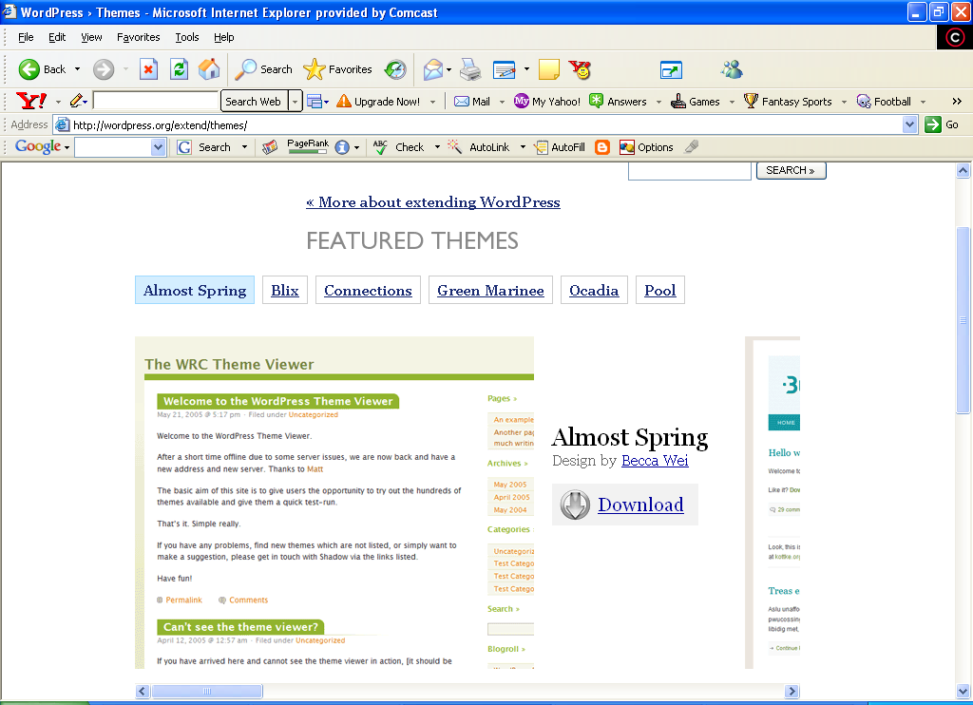
These are the default themes that are provided with Wordpress. You can do customized themes, but that is beyond the scope of this report. You can see that if you want to download the “Almost Spring” theme, you can click the “Download” button. This will download the folder shown below:

Here I have downloaded the “Connections” theme. It is a simple folder. You will take the theme you downloaded and copy the whole folder into the themes folder on your website. Looking at the next page, you can see the destination of this folder in the target website.

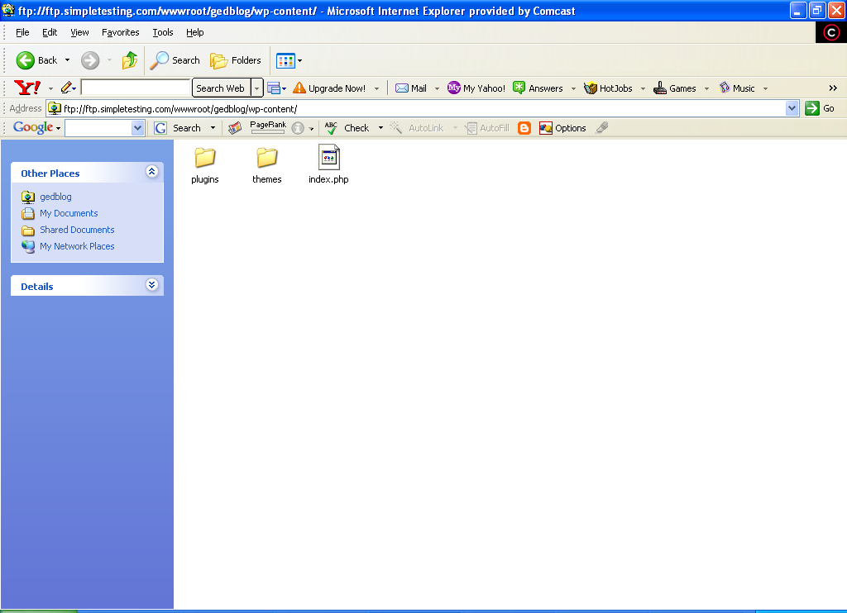
You are going to copy this whole folder into the directory structure below:
- Top-level
- wp_content
- Themes
- Copy your folder into the themes directory
- The new theme will appear in your administration console. You can now select it from your collection of themes.
Templates and themes are somewhat the same in Wordpress. The word theme is commonly described as the “look and feel” of a page. For instance, a forest theme would probably entail images of leaves and greenery somewhere on the page. The actual “template” for the page would be the layout of the webpage itself. The best way to differentiate these two concepts is that the theme is the “look and feel” and the ‘template’ is the page that provides the layout. We will briefly describe what capabilities you have within the use of templates. We won’t kill you with a mountain of technical information but we will let you know the capabilities you have inside Wordpress. You can:
- Modify Themes
- Modify template pages
- Modify images in the themes
- Import a “theme within a theme”
- Change page header information
- Embed forms in templates
- Embed plugins in templates
- Add feeds and RSS
- Administer over SSL
- Add filters
- Create custom error pages
- Modify the arrangement of template tags, thusly rebuilding composition of the template

Wordpress templates use custom template tags that populate from the database at run-time. It is an advanced topic, but you can rearrange and play with these tags. This is actual programming and is not a part of this book. You should know that this is possible, but in no way required to make every change you could possibly want.

Free Wordpress Template & Theme Resources
Listed below is a list of free Wordpress Template resources:
- www.tastystock.com
- www.lifehacker.com
- chris.lineages.co.uk
- www.andreasviklund.com
- themes.wordpress.net
- blogging.typepad.com
- www.entheosweb.com
- www.freewebsitetemplates.com
- www.freelayouts.com
- http://redalt.com/External/plugins.php
- www.wp-plugins.net
- www.blogginpro.com
- www.johntp.com/2006/04/06/wordpress-plugins/

Best Paid-For Wordpress Template Resources
- www.clantemplates.com
- www.adesdesign.net
- www.tammyhartdesigns.com
- www.perfectory.com
- www.finerdesign.com
- www.spidean.com
- www.templatefolio.com

Wordpress Plugin Basics
What is a plugin? A plugin is a software addition that adds extra benefits and features to your website. Some plugins add advertising, and monetizing to your website. Others add links and feeds and other special features. Listed below are the plugin categories that Wordpress allows:
- Administration
- Business and Monetizing
- Design, Layout and Styles
- Graphics, Video and Sound
- Links
- Odds and Ends
- Outside Information
- Posts

Here's a few examples from these general categories showing plugins that serve each purpose.

Administration Plugins – These plugins help you administer your website more effectively. These include spell check, crawl page generation for posts and a host of other capabilities.
Business and Monetizing Plugins – These plugins have the ability to build in a shopping cart, sell items from CafePress, and create surveys that give you financial credit.
Design, Layout and Styles – These plugins include customizable post listings, auto-archiving, recent comments, most recent updates are showcased on the website, and recent posts.
Graphics, Video and Sound – Coolplayer will allow multimedia content to play, and user audio on-line.
Odds and Ends (Miscellaneous) – These plugins include financial information, weather, geomapping data, user forums, date and time information.
Links – These plugins include Blog links, link checker, Google Pics, Incoming Links, and random linking system.
Outside Information – These plugins import external data from outside the Wordpress website. Data like Amazon.com, Media Press, and Blog It information.
Posts – These allow for cellphone-based blog posts, Bible posts, browser blog and exceptions, and many other types of posts.

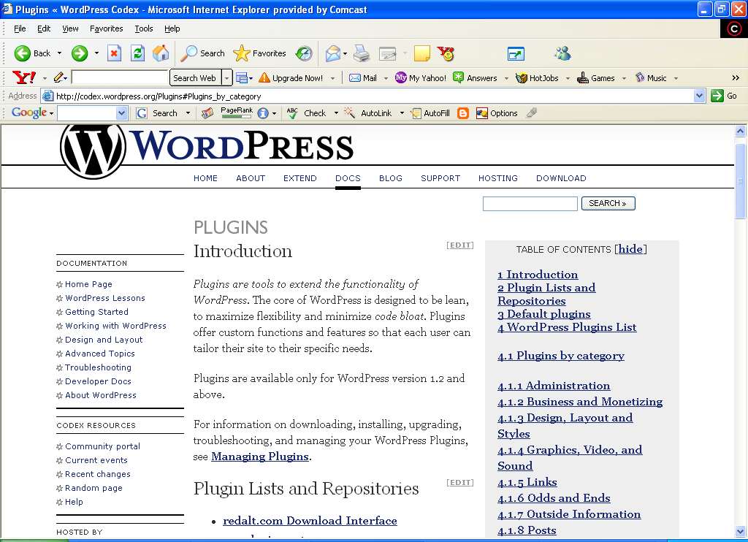
Why Plugins?
Plugins are very important. You need to understand that monetizing the blog is critical. Plugins function to increase interest in your pages and provide extended functionality. The ability to leave messages via cellphone or do podcasts may increase the traffic to your blogs. The actual attraction to Blogger.com is the ease of monetization. You need to decide how you will generate income in your Wordpress page. You have a few options like:
- Shopping cart
- CafePress
- On-line Surveys
- Google Adsense
- Commission Junction
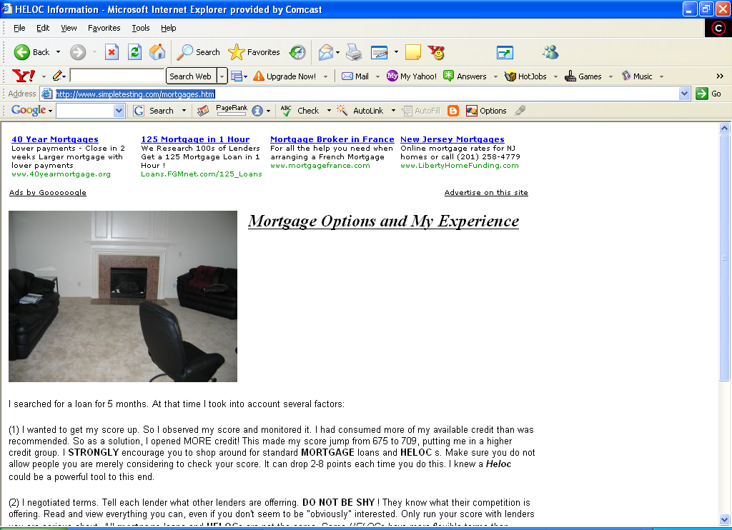
The last two of these monetization tools (shown above) give you the ability to generate income simply from the people who visit your blog/website. You simply need to alter your templates to include plugins that can work with these tools. The other tools require you to purchase items, but they can produce more income than the pay-per-click items you see below. Pay-per-click often only generates pennies or just a few dollars per day. Shopping can create a lot more cash per transaction, but often there are a fewer transactions. Some traffic building tips were shared earlier about how to arrange your blogs in relation to a main website to maximize traffic.

How to Install Plugins
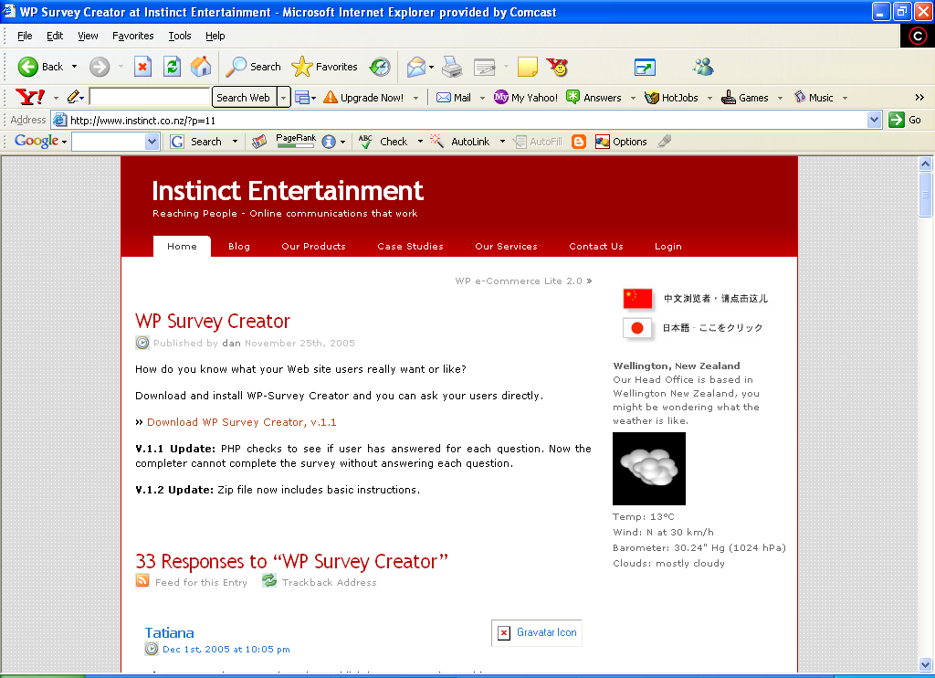
1. In this example we will download the WP Survey Plugin. We will navigate to the main website and then save off the Winzip file.
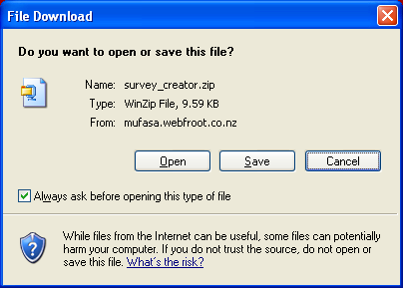
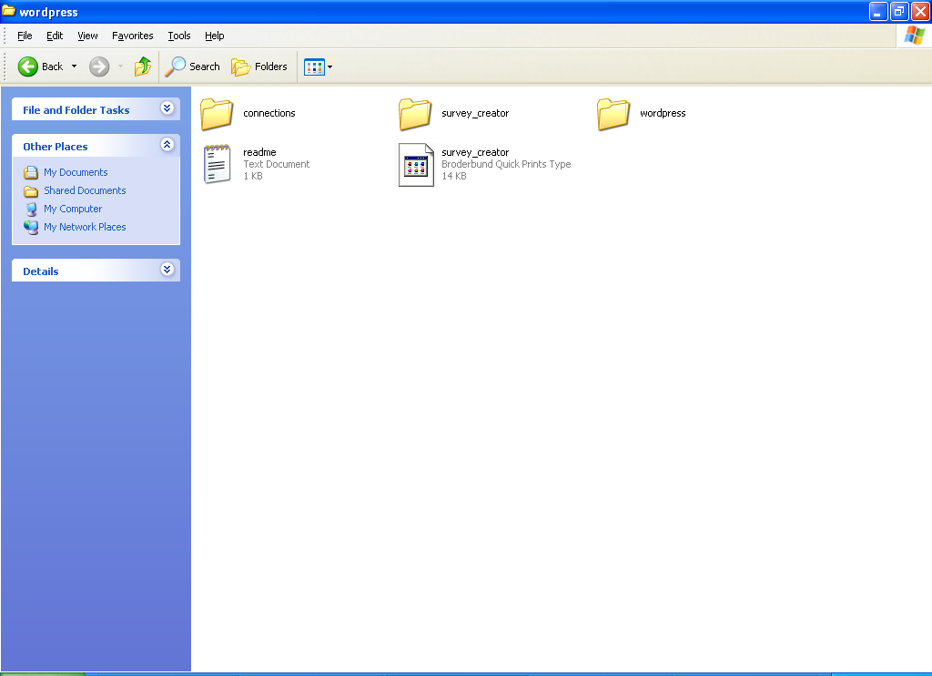
2. Here your Wordpress file will extract to a “survey_creator” file. You would then open your FTP connection to your website and “paste this folder into your plugins folder”.
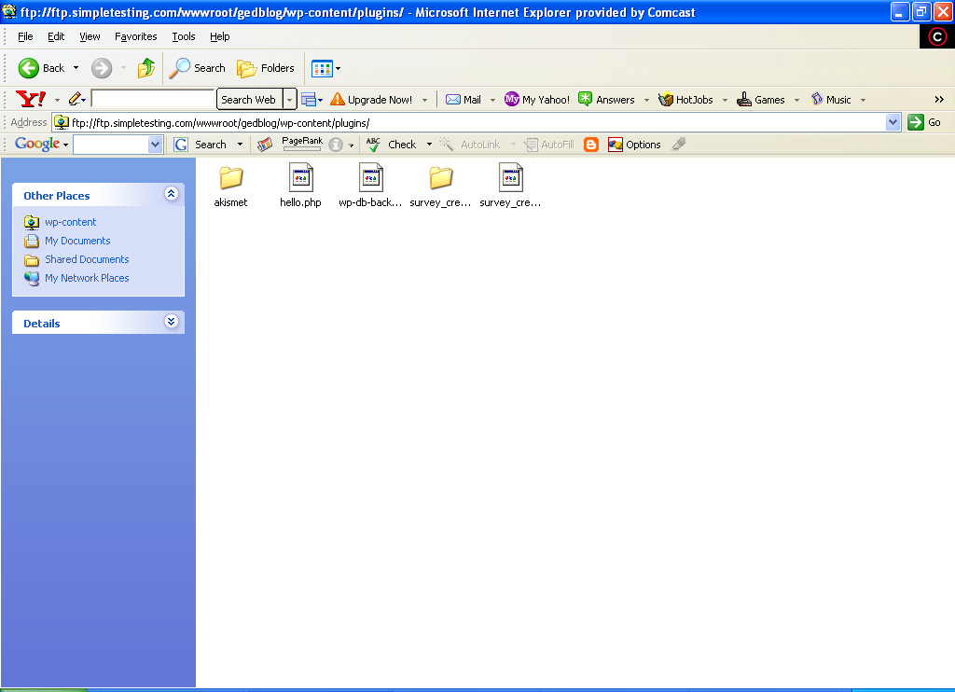
3. Once the survey_creator folder is pasted into the ../wp_contents/plugins folder, you will then be able to select the survey_creator plugin from your administration panel.

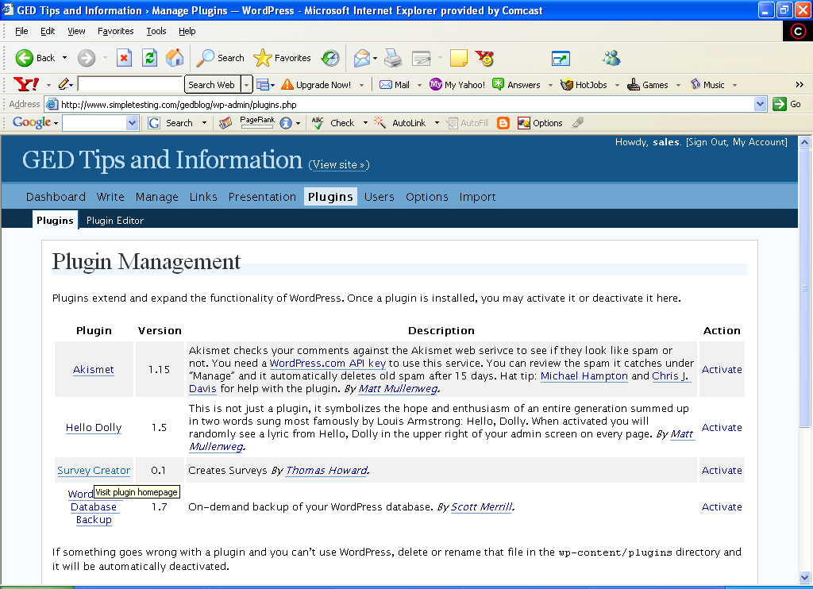
4. Survey Creator now appears in your plugin list, and you can activate it and use it as you see fit.
5. You then click “Activate” from the action menu on the left. Now the plugin is available through your blogs and pages. It is that EASY!!

Free Wordpress Plugin Resources
- www.pingmaj.jp
- dev.wp-plugins.org
- weblogs.about.com
- www.skipy.net
- www.adesblog.com
- www.theblog.cc
- www.siteground.com
- www.johntp.com

Conclusion
Wordpress continues to release quality versions of their already stable product as well as extend users’ capability to produce quality websites. Wordpress also has a community theme viewer that allows you to view hundreds of new themes produced by other programmers. This gives the user the ability to see what others have dreamed up.

Wordpress is a quality product that allows you with very little knowledge to assemble, and deploy a beautifully complex website with little technical knowledge, and experience. The user gets the ability to use various themes and templates to make a professional impact on his/her user community. Wordpress is an awesome tool. If you are not using Wordpress to build your websites then you are spending a lot of time doing work you don’t have to do.

